**Boston University**

**Electrical & Computer Engineering**

**EC463 Senior Design Project**

**First Prototype Testing Plan**

**Future of Heat**



**By**

**Team 17**

**Future of Heat**

Team Members

Andrew Chen, achen17@bu.edu

Ben Gross, bengee19@bu.edu

Muayad Al Riyami, mriyami@bu.edu

Fatima Dantsoho, dantsoho@bu.edu

Seunghak Shin, seunghak@bu.edu

**Required Materials**

**Hardware:**

* Arduino Mega 2560 Rev3
* Espressif ESP8266 Wi-Fi Module
* LED diodes (red and green)
* RGB LEDs
* Assortment of capacitors, resistors, and inductors
* 12V DC Power Adapter

**Software**

* Web application hosted on Firebase
* Natural Gas and Electric Heating Pricing APIs
* New England Weather API

**Set Up**

The equipment and setup are divided into three major parts, the RLC circuitry that represents the power grid and the residential house’s loads, the Arduino Mega used in conjunction with the ESP8266 WiFi Module to receive and send data to the last project component, the web application portal. The web app sends data regarding the number of houses with electric heating as well as temperature values to the Arduino. The Arduino takes this information and selectively puts output pins to HIGH such that specific diodes light up green or red to represent electric and gas heating respectively. Additionally, it uses the WiFi module to set up a small server to push power load readings to the web app.

As of right now, the prototype is far from complete, as it focuses mainly on a one house sub unit and most required materials are still in the ordering process. As such, the current prototype consists of an Arduino UNO in lieu of the Arduino Mega, with the WiFi module component currently excluded. Additionally, currently only pure resistance power loads can be measured. Lastly, RGB LEDs to display homes heating up via a gradient between blue to red light is also excluded.

**Pre-testing Procedure**

Arduino UNO side:

1. Ensure the code can be uploaded correctly.
2. Open the serial monitor to see real time voltage and power readings.

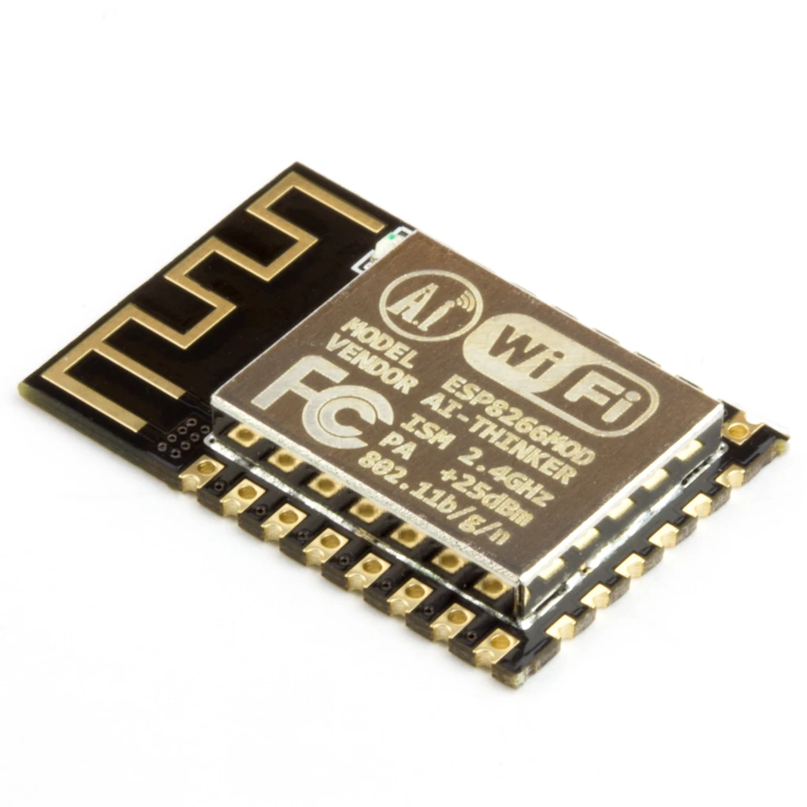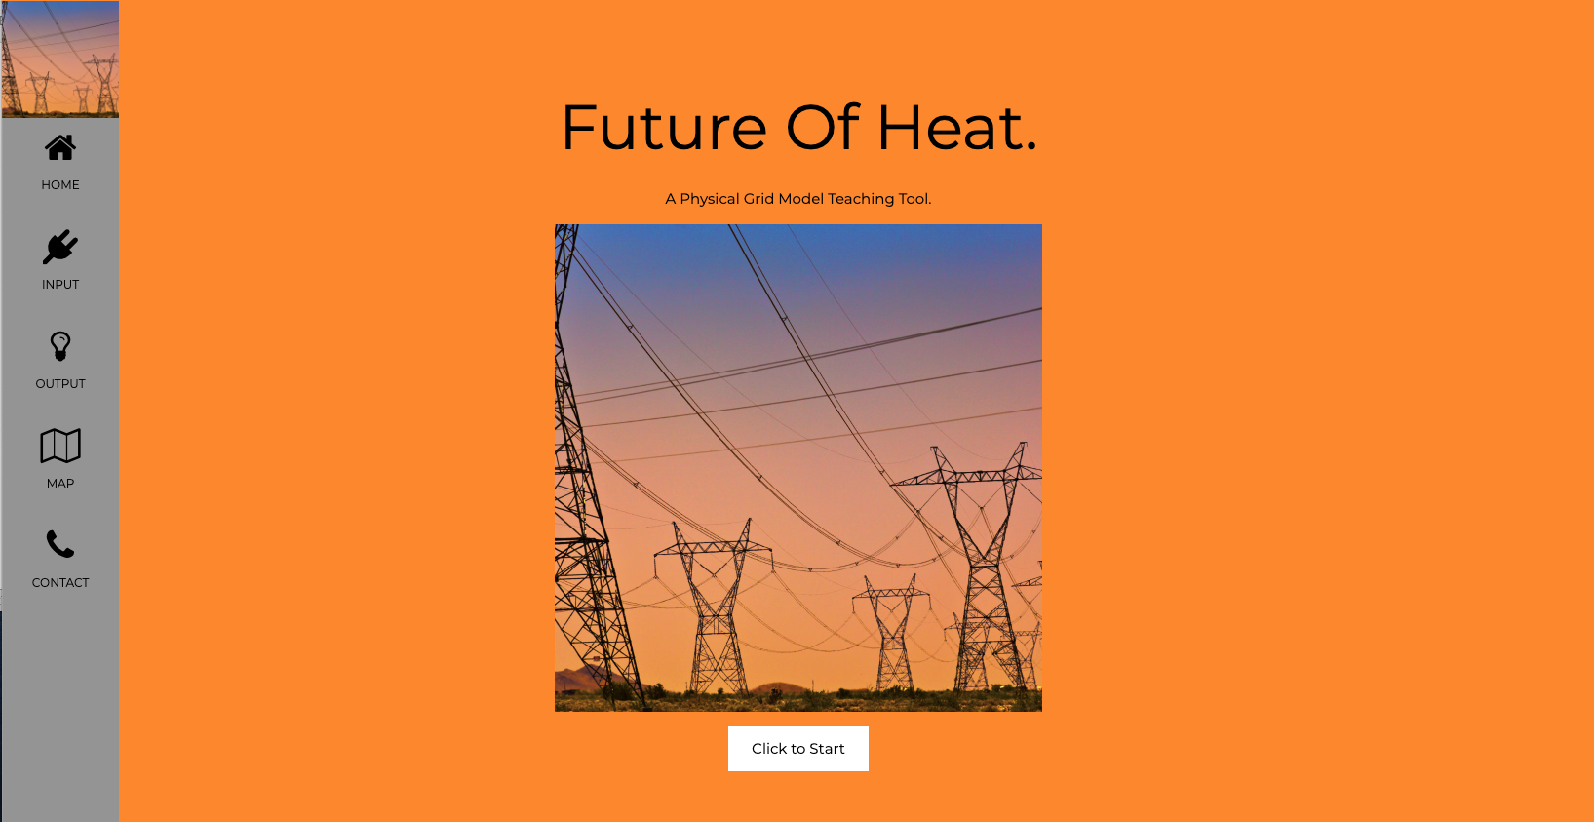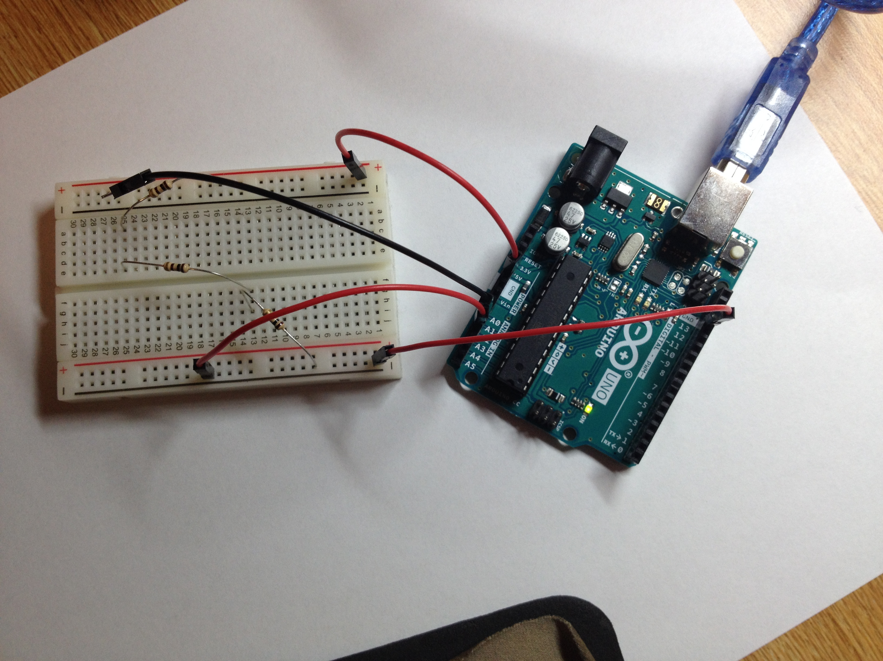



*Figure 1: Illustration of Final Setup and Process Flow*

Web Application:

1. Ensure the code runs correctly.
2. Open HTML on the web browser.

**Testing Procedure**

1. Given a purely resistive circuit representation of housing loads, use pins A0 (GND) and A1(Target) to probe for voltage. Edit the corresponding resistance variable within the Arduino code.
2. Using the Serial Monitor, find instantaneous circuit values, type P to measure power, S to pause the measurements, and V to measure voltage. Typing in N (natural gas) or E (electric) into the serial monitor results in the red and green LEDs to turn on respectively.
3. Use range sliders in the web application to select the user input.
4. Hover over the interactive map objects to make sure the housing and vehicle power information are properly displayed.

**Measurable Criteria**

The criteria for successful running and output is as follows:

1. Correct voltage and power loads sensor readings within a margin of error of 5%.
2. The Arduino should light up the Red LED if “N (Natural Gas Heating)” is entered in the serial monitor and should light up a Green LED if “E (Electric Heating)” is entered in the serial monitor.
   1. This criteria is meant to mimic LED control, of course once the WiFi module is set up the control for the LEDs would be inputted by the user on the web app.
   2. Currently this is only representative of LEDs needed for one house (excluding the RGB LED), current amplification may be needed to power all the LEDs for the finished product, additionally a decoder will most likely be used to service all the LEDs at various houses.

**Scoresheet**

|  |  |  |  |  |  |  |  |
| --- | --- | --- | --- | --- | --- | --- | --- |
| Load Resistance | VTheoretical | VActual | PTheoretical | PActual | V % Error | P % Error | LEDs Correct? |
| 100 Ω | $1.\underline{6}$ V |  | $0.02\underline{7}$ W |  |  |  |  |
| 200 Ω | $3.\underline{3}$ V |  | $0.0\underline{5}$ W |  |  |  |  |
| 300 Ω | 5.0 V |  | $0.08\underline{3}$ W |  |  |  |  |
| Result → | | | | | | | |

**Circuit Diagram and PinOut**

*Figure 2: Pinouts and Circuit Diagram of Current Arduino Control*

|  |  |
| --- | --- |
| Arduino UNO Pin# | Usage and Description |
| A0 | Ground → Arduino GND Probe for Voltmeter |
| A1 | VLoad→ Arduino V Probe for Voltmeter |
| D6 | Digital Output Pin → Green LED diode |
| D7 | Digital Output Pin → Red LED diode |

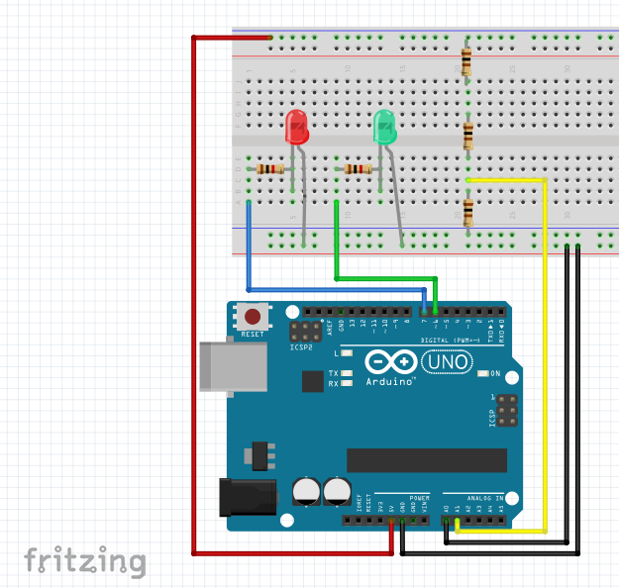

*Figure 3:Theoretical Circuits to Represent Residential Loads*

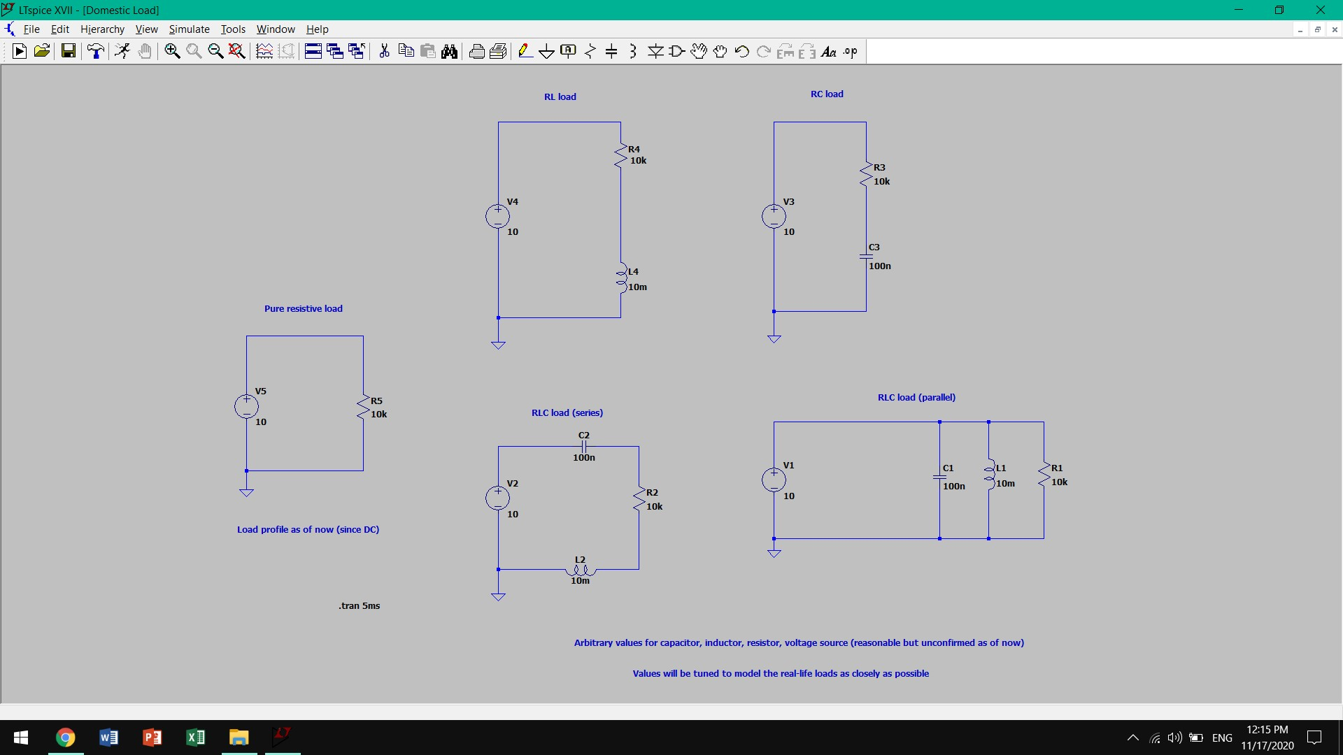

Current prototype testing parameters:

* Purely resistive load (represents heating)
* Non-purely resistive loads are currently trivial and as it is DC circuit (w = 0)
* Power load simply equals (voltage across resistor) squared divided by its resistance